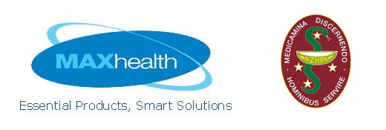**Max Health Innovation Grant 2024**

* Do you have a great idea for improving patient care?
* Are you struggling to implement a new model of service due to lack of resources?
* Got the initiative but need the support?
* Would like complimentary registration to NZHPA Conference?

**If the answer is yes, this award could be for you!**

**Max Health, a small and innovative NZ based company, are proud to offer this $3000 prospective award to support research and professional development in areas that align with the values of Max Health:**

* **Innovation in pharmacy practice**
* **Problem solving**
* **Exceeding customer expectations**

Submit your proposal and you could be one of the finalists invited to pitch your idea to a panel of judges via Teams in September 2024. The winner will receive **complimentary registration** to the 2024 NZHPA Conference in Dunedin (23 – 24 Nov) to present their winning idea.

The award can be used to support service improvement initiatives, research projects, national or international study tours, preceptorships, international and local travel to relevant conferences.

**Eligibility Criteria**

* Applications must demonstrate innovation in pharmacy practice, problem solving or exceeding customer expectations.
* Work can be current, prospective, or retrospective work (within the last 12 months) that you wish to develop further.
* Applicants must be current ordinary members of NZHPA

**Application Process**

Complete the online application form for Max Health Innovation Grant found on the NZHPA website at <https://nzhpa.org.nz/grants/max-health-innovation-grant/> by **5pm** **Friday 6 Sept 2024**

If you have any questions please contact Lisa, NZHPA Administrator:[nzhpa@nzhpa.org.nz](mailto:nzhpa@nzhpa.org.nz)